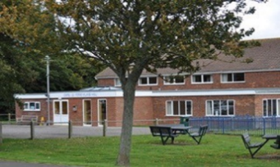**CAPEL-LE-FERNE VILLAGE HALL**

**REGISTERED CHARITY No. 281786**

**The Village Hall, Lancaster Avenue, Capel-le-FerneCT18 7LX**

**100+ Club 2023/2024**

**Subscriptions to the 100+ club have now expired and you are invited to take out/renew a subscription for the forthcoming year. All Forms to be returned by the 31st August to be entered into September 2023 Draw.**

**For the outlay of just £1 per month (£12 for the whole year) you will be entered into a monthly draw for cash prizes - £25/£15/£5 each month, doubled at Christmas. The draw usually takes place at the Village Hall Committee Management Meeting on the first Tuesday of each month.**

**Profits go to the continuing refurbishment of the hall.**

**To renew your or take out a new subscription, please give this form and your money to Caroline Bunting, 3 Crete Road East (post it though my letterbox please) or hand to Sally Cook or Cherry Leppard at Farmers Market on Tuesdays.**

**Cheques should be made payable to ‘Capel-le-Ferne Village Hall’.**

**If you know anyone else who would like to join, please copy this form or advise Caroline on 07885 406433.**

**++++++++++++++++++++++++++++++++++++++++++++++++++++++++++**

**Name. .............................................................. Phone No. ...................................**

**New number please ........ (If available), or keep the number you have ..........**

**Address. ................................................................................................................**

**..............................................................................Postcode..................................**

**Email address: ...................................................................................................**